UID EXPERIMENT – 8

NAME: DURKASRI REG NO: 240701132

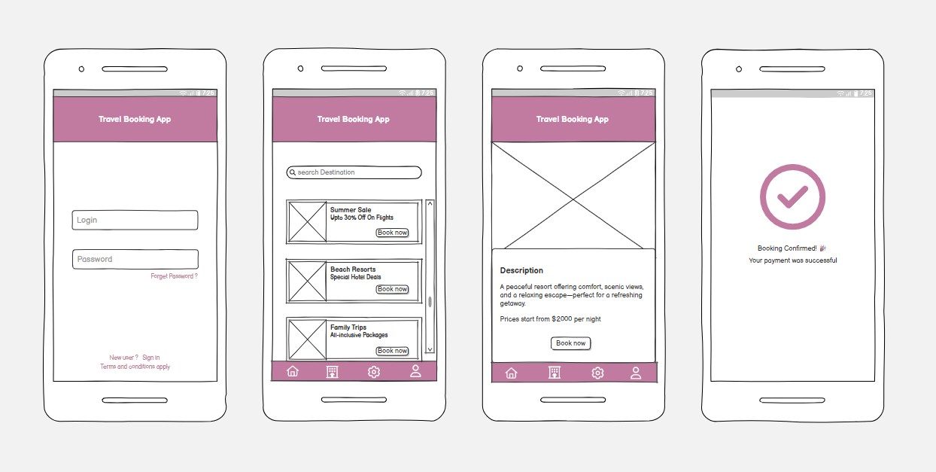
WIREFRAME: Travel Booking App
Screen 1: Login Page
- Entry point of the application
- Allows users to enter login credentials (username/email & password)
- Includes “Forgot Password” option for recovery
- Provides sign-up option for new users
- Ensures secure user authentication

Screen 2: Home / Dashboard
- Main interface to explore travel options
- Search bar to find destinations
- Displays offer like flights, resorts, and packages
- “Book Now” button for quick booking
- Bottom navigation bar for easy app navigation

Screen 3: Resort Details Page
- Shows detailed information about selected resort/package
- Includes image placeholder for visuals
- Provides description of the resort
- Displays price range (per night)
- “Book Now” button to proceed with booking

Screen 4: Booking Confirmation
- Displays confirmation after successful booking
- Shows checkmark icon for visual confirmation
- Indicates payment was successful
- Provides reassurance and completion of booking process

WIREFRAME LINK:
https://balsamiq.cloud/s629pim/pug0tfr/rA310?f=N4IgUiBcCMA0IGEpxAGWfAQhkAtHA0lANoC6AvkA

